LOGININFO:

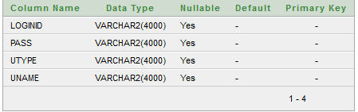

MARKET_NAME_TAB:

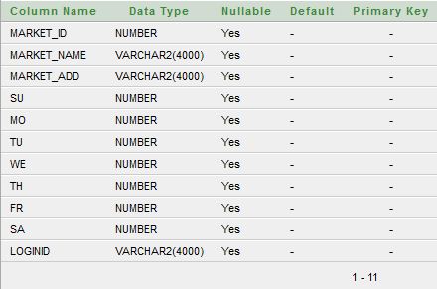

USERINFO:

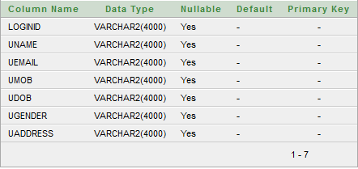

VEG_MARKET_PRICE_TAB:

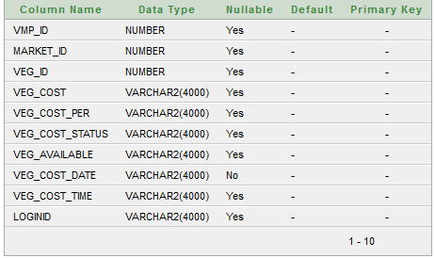

VEG_NAME_TAB:

